EX 1: Study Planner Application
Aim
To develop a simple cloud-based Study Planner application that helps users organize their study tasks, set deadlines, and track progress using a SaaS platform.
Algorithm
- Start
- Create a study planner form
- Enter task details (subject, task, date, status)
- Store the data in cloud database
- Display tasks in a list format
- Allow user to update task status (Pending/Completed)
- Repeat for multiple tasks
- Stop
Procedure
- Open Zoho Creator
- Create a new application named Study Planner
- Create a form called Study_Tasks
- Add the following fields:
  - Task_ID (Auto Number)
  - Subject (Single Line)
  - Task_Description (Multi Line)
  - Due_Date (Date)
  - Status (Dropdown: Pending, Completed)
- Save the form
- Create a report to view tasks
- Enter sample data and test the application
- Deploy the application to cloud

Output
- User can add study tasks
- Tasks are displayed in a structured list
- User can track due dates and completion status
- Data is stored and accessed through cloud
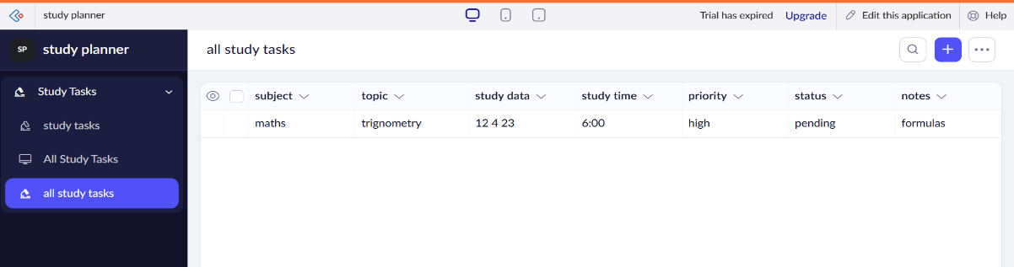

Result
A simple cloud-based Study Planner application was successfully developed using Zoho Creator. The system allows users to manage study tasks efficiently and demonstrates the SaaS model through online accessibility and centralized data storage.

Flight Reservation System
Aim
To develop a simple cloud-based Flight Reservation System that allows users to view flight details and make bookings using a SaaS platform.
Algorithm
- Start
- Create flight reservation form
- Enter user details (name, flight, date)
- Store booking information in cloud database
- Display available flights
- Allow user to select and reserve a flight
- Save booking details
- Stop
Procedure
- Open Zoho Creator
- Create a new application named Flight Reservation System
- Create a form called Flight_Booking
- Add the following fields:
  - Booking_ID (Auto Number)
  - Passenger_Name (Single Line)
  - Source (Dropdown: Chennai, Delhi, Mumbai)
  - Destination (Dropdown: Chennai, Delhi, Mumbai)
  - Travel_Date (Date)
  - Number_of_Seats (Number)
  - Total_Price (Currency)
- Save the form
- Create a report to view bookings
- Enter sample data and test the system
- Deploy the application to cloud
Output
- User can enter booking details
- Flight reservation data is stored in cloud
- Bookings can be viewed and managed easily
- System provides simple reservation functionality
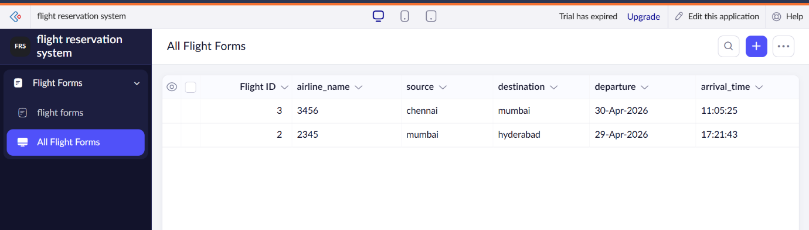
Result
A simple cloud-based Flight Reservation System was successfully developed using Zoho Creator. The system allows users to reserve flights online and demonstrates the SaaS model through browser-based access and centralized data management.

